Data Analysis Report[Airbnb Listings]

OBJECTIVE
In this project report we are aimed to analyze the given dataset and first to scraped the data and then find the answers to few questions i.e. Which area is most expensive and what are the features that leads to higher price of the airbnb.
Data cleaning:
This step is focused on cleaning the dataset to make it more suitable and effective for training machine learning models and performing data analysis. The cleaning process is structured in multiple stages, detailed as follows:

1. Dropping Irrelevant Columns:
The first step involves eliminating columns that are not useful for our analysis. This step is intentionally done before handling missing values, because the dataset initially contains 78 columns, and blindly cleaning all of them would be inefficient and unnecessary.
The logic behind removing these columns was simple: if a column doesn’t contribute any meaningful information or is unrelated to the core questions we aim to answer through this analysis, we dropped it. This allowed us to reduce the dataset to only the most relevant features.
The columns we removed include:
"id", "listing_url", "scrape_id", "last_scraped", "source", "name", "description", "neighborhood_overview", "picture_url", "host_id", "host_url", "host_name", "host_since", "host_about", "host_response_rate", "host_acceptance_rate", "host_thumbnail_url", "host_picture_url", "host_listings_count", "host_verifications", "host_has_profile_pic", "neighbourhood", "neighbourhood_group_cleansed", "latitude", "longitude", "room_type", "bathrooms", "bathrooms_text", "beds", "minimum_nights", "maximum_nights", "minimum_minimum_nights", "maximum_minimum_nights", "minimum_maximum_nights", "maximum_maximum_nights", "minimum_nights_avg_ntm", "maximum_nights_avg_ntm", "calendar_updated", "has_availability", "availability_30", "availability_60", "availability_90", "availability_365", "calendar_last_scraped", "number_of_reviews_ltm", "number_of_reviews_l30d", "availability_eoy", "number_of_reviews_ly", "estimated_occupancy_l365d", "estimated_revenue_l365d", "first_review", "last_review", "license", "instant_bookable", "calculated_host_listings_count", "calculated_host_listings_count_entire_homes", "calculated_host_listings_count_private_rooms", and "calculated_host_listings_count_shared_rooms".

We used the following command to drop these columns:
>>>df.drop(columns=['column_name1', 'column_name2', ...], inplace=True)

2. Checking for Missing Values:
In the next step, we examined how many missing values were present in the dataset using the .isnull().sum() function:
python
CopyEdit
>>> df.isnull().sum()
This gave us the following output:
yaml
CopyEdit
host_location 6624
host_response_time 4066
host_is_superhost 1319
host_neighbourhood 18115
host_total_listings_count 2
host_identity_verified 2
neighbourhood_cleansed 0
property_type 0
accommodates 0
bedrooms 1281
amenities 0
price 5390
number_of_reviews 0
review_scores_rating 9466
review_scores_accuracy 9466
review_scores_cleanliness 9467
review_scores_checkin 9470
review_scores_communication 9467
review_scores_location 9471
review_scores_value 9472
reviews_per_month 9466
From the output, we can clearly see that many columns have missing values. However, since a large number of these values are missing, we cannot simply drop all the columns that contain nulls — doing so would severely affect our analysis and potentially eliminate important insights.

Therefore, to clean the data effectively while preserving the accuracy of our analysis, we need to handle missing values using different strategies and logic tailored to the nature of each column.

Code Block:
df['host_location'].fillna('unknown', inplace=True)
Fills missing values in the host_location column with 'unknown', indicating that the host's location is not provided.

df['host_response_time'].fillna("N/A", inplace=True)
Replaces missing values in the host_response_time column with "N/A", marking that the response time is not available.

df['host_is_superhost'].fillna("", inplace=True)
Fills missing values in the host_is_superhost column with an empty string, meaning the superhost status is not mentioned.

df['host_neighbourhood'].fillna("other", inplace=True)
Substitutes missing host neighborhood values with "other", acting as a generic placeholder for unknown or unspecified areas.

df['host_total_listings_count'].fillna(0, inplace=True)
Replaces missing values with 0 in the host_total_listings_count column, assuming no listings if not specified.

df['host_identity_verified'].fillna('f', inplace=True)
Fills missing verification status with 'f', indicating the host's identity is not verified if the information is missing.

df['bedrooms'].fillna(1, inplace=True)
Replaces missing bedroom values with 1, using a minimal sensible default.

df.dropna(subset=['price'], inplace=True)
Drops rows where the price column is missing, as price is essential for analysis.

df['review_scores_rating'].fillna(0, inplace=True)
Fills missing values in review_scores_rating with 0, suggesting no rating is available.

df['review_scores_accuracy'].fillna('N/A', inplace=True)
Replaces missing accuracy review scores with "N/A", indicating the value is not recorded.

df['review_scores_cleanliness'].fillna('N/A', inplace=True)
Fills missing cleanliness scores with "N/A" to mark them as unavailable.

df['review_scores_checkin'].fillna('N/A', inplace=True)
Substitutes missing check-in scores with "N/A" to show the data is not present.

df['review_scores_communication'].fillna('N/A', inplace=True)
Replaces missing communication scores with "N/A", indicating that no review is provided for this metric.

df['review_scores_location'].fillna('N/A', inplace=True)
Fills missing values in the location review score column with "N/A".
df['review_scores_value'].fillna('N/A', inplace=True)
Substitutes missing value-for-money review scores with "N/A".

df['reviews_per_month'].fillna('N/A', inplace=True)
Fills missing review frequency (reviews_per_month) with "N/A", showing no review activity is available.

3. Checking for valid datatypes: This step includes checking datatype of all the columns and matching it with the actual demand of that column like date column must be in the date time format, Here, the price column is of dtype 'object' so we have to change it to integer.
Code block: df['price']=df['price'].astype('float')
EDA[Exploratory Data Analysis]:
In this step, we took a deeper look of a data, digging bit more using commands like df.head(), df.tail(), df.shape, df.describe and groupby. Here is how we did this step:
- Firstly we started with taking a overall look of the data using commads:
>>df.head(): to print first 6 values.
>>df.tail(): to print last 6 values.
>>df.shape: to print the shape of the dataset.
>>df.describe(include=’object’)
>>df.info()
- Then we began digging bit deeper into it using groupby command and exracting the informations so as to understand diffrerent trends, and dependencies of the features, we carried out this step as:
- First we grouped the host_location in accordance of price and sorted the values so as to get the location with the highest price.
>>>df.groupby('host_location')['price'].sum().sort_values(ascending=False)
- As we know, we have to find the area with highest price, to do so, we grouped host_location in accordance of price and the constraint we put was mean, at last we sorted all the values.
Code block:
>>>df.groupby('host_location')['price'].mean().sort_values(ascending=False)
From this command we got that the most expensive area is ‘Caloocan Philippines’

FEATURE ENGINEERING:
This step includes adding new column out of present columns, so as to make our further analysis easy and sometimes without doing so we cannot move further, Here, in this analysis we require amanities_count since, amanities column can not be used directly along with this column is one of the most important factor and the price genrally depends the amanities provieded by a particular hotel or airbnb.
Code block:
df['amenities_count'] = df['amenities'].apply(lambda x: len(x.split(',')) if pd.notnull(x) else 0)

Now finding features correlated to Price, as we have to find the features leading higher prices:
For this step the heatmap will be best as with this plot we can efficiently show which feature depends or correlates to a particular feature or not with the help of different colours.
We carried out this step as:
>>>numeric_features = ['price', 'accommodates', 'bedrooms', 'number_of_reviews', 'review_scores_rating', 'amenities_count']
This line defines a list of selected numeric features from the dataset that are considered important for analysis. These features include price, accommodates, bedrooms, number_of_reviews, review_scores_rating, and amenities_count.
>>>corr = df[numeric_features].corr()
This line computes the correlation matrix for the selected numeric features using the .corr() method. It measures the strength and direction of relationships between the variables.
>>>plt.figure(figsize=(10, 6))
This line sets the size of the figure to 10 inches wide and 6 inches tall, which helps in better visualizing the heatmap without crowding.
>>>sns.heatmap(corr, annot=True, cmap='coolwarm')
This line generates a heatmap using Seaborn to visually represent the correlation matrix. The annot=True argument displays the actual correlation coefficients inside the heatmap cells, and cmap='coolwarm' sets the color scheme, where blue typically represents negative correlation and red represents positive correlation.
>>>plt.title("Correlation with Price")
This line adds a title to the heatmap plot, making it clear that the purpose of the visualization is to show how different features correlate with the price.
>>>plt.show()
This line displays the final heatmap plot. Without this command, the plot may not be rendered in some environments.

The plot is like:

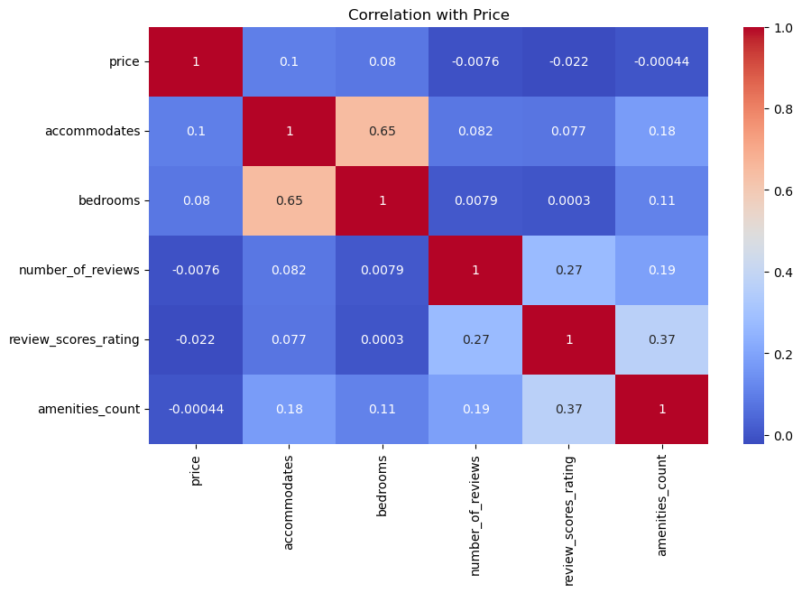

With this plot we can conclude that:
The price is influenced by 'accommodates', 'bedrooms', 'number of amaneties', 'review score rating.

FINAL ANALYSIS:
The most expensive Airbnb listing is located in Bangkok, Thailand.
The most expensive overall area, based on average prices, is Calcoon, Philippines.
The features that are most strongly associated with higher prices include:
- Number of accommodates – listings that can host more guests generally cost more.
- Number of bedrooms – more bedrooms typically indicate larger properties with higher pricing.
- Number of amenities – properties offering a greater number of amenities tend to be priced higher.
- Review score rating – listings with higher ratings are often more desirable and thus more expensive.

QUESTIONS ASKED:
- Which area is the most expensive area?
Ans) Calcoon Philippinnes
- Which features leads to higher prices?
Ans) The features that are most strongly associated with higher prices include:
- Number of accommodates – listings that can host more guests generally cost more.
- Number of bedrooms – more bedrooms typically indicate larger properties with higher pricing.
- Number of amenities – properties offering a greater number of amenities tend to be priced higher.
- Review score rating – listings with higher ratings are often more desirable and thus more expensive.

